**Practices - Section 5**

**Practice 5-1: Determining color in the visible spectrum:**

Write an interactive Java program, ColorRange.java, which when given a wavelength in nanometers will return the corresponding

color in the visible spectrum.

Task

You must implement the following using a suitable if decision statement.

1. Prompt the user to enter the wavelength, the wavelength should be of

type double.

2. For each range (e.g. 380-450) the number on the left is included in the

range, but the number on the right is not included in the range.

3. If the input value is not found on the visible spectrum then state that

the wavelength is not within the visible spectrum.

4. Expected Output:

a. Enter a color code

630

The color is Red

b. Enter a color code

25.0

The entered wavelength is not a part of the visible spectrum

c. Enter a color code

750.5

The entered wavelength is not a part of the visible spectrum

The ColorRange.java file is available to help you get started.

Color Wavelength (nm)

Violet 380-450

Blue 450-495

Green 495-570

Yellow 570-590

Orange 590-620

Red 620-750

**Coding:**

import java.util.Scanner;

public class ColorRange {

public static void main(String[] args) {

Scanner scanner = new Scanner(System.in);

// Prompt the user to enter the wavelength

System.out.print("Enter a color code: ");

double wavelength = scanner.nextDouble();

// Determine the color based on the wavelength

String color;

if (wavelength >= 380 && wavelength < 450) {

color = "Violet";

} else if (wavelength >= 450 && wavelength < 495) {

color = "Blue";

} else if (wavelength >= 495 && wavelength < 570) {

color = "Green";

} else if (wavelength >= 570 && wavelength < 590) {

color = "Yellow";

} else if (wavelength >= 590 && wavelength < 620) {

color = "Orange";

} else if (wavelength >= 620 && wavelength <= 750) {

color = "Red";

} else {

color = null;

}

// Output the result

if (color != null) {

System.out.println("The color is " + color);

} else {

System.out.println("The entered wavelength is not a part of the visible spectrum");

}

}

}

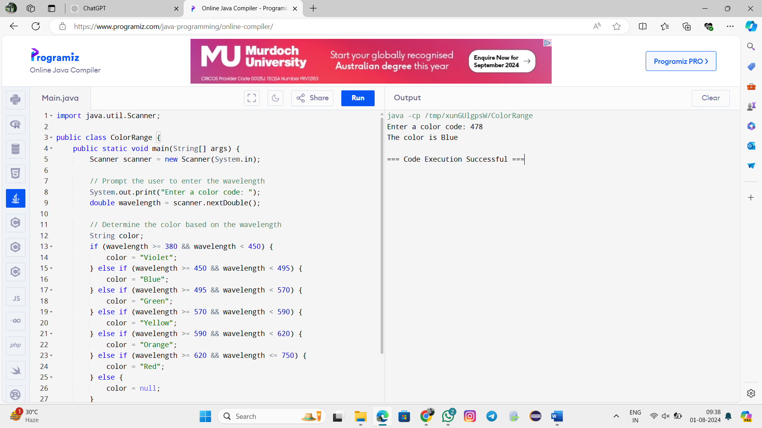

**Problem 5-2: Determining the next color for a stop light:**

The normal behavior for a stop light is to cycle from Red to Green to Yellow to Red (and continues with this pattern). Write a java

program TrafficLightChecker.java, which will determine the next color of a stop light in this pattern, Red to Green to Yellow to

Red based on the current stop light provided by the user.

Task:

You must implement the following using a suitable if decision statement.

1. Have the user enter the value for the currentColor.

2. Compute the next color stop light based on the currentColor.

3. Alert the user for any invalid value of color.

Expected Output:

a. Enter a color code

1

Next Traffic Light is green

b. Enter a color code

3

Next Traffic Light is red

c. Enter a color code

0

Invalid color

d. Enter a color code

4

Invalid color

The TrafficLightChecker.java file is available to help you get started.

**Coding:**

import java.util.Scanner;

public class TrafficLightChecker {

public static void main(String[] args) {

Scanner scanner = new Scanner(System.in);

// Prompt the user to enter the current color code

System.out.print("Enter a color code (1 for Red, 2 for Green, 3 for Yellow): ");

int currentColor = scanner.nextInt();

// Determine the next color based on the current color

String nextColor;

if (currentColor == 1) {

nextColor = "Green";

} else if (currentColor == 2) {

nextColor = "Yellow";

} else if (currentColor == 3) {

nextColor = "Red";

} else {

nextColor = null;

}

// Output the result

if (nextColor != null) {

System.out.println("Next Traffic Light is " + nextColor.toLowerCase());

} else {

System.out.println("Invalid color");

}

}

}

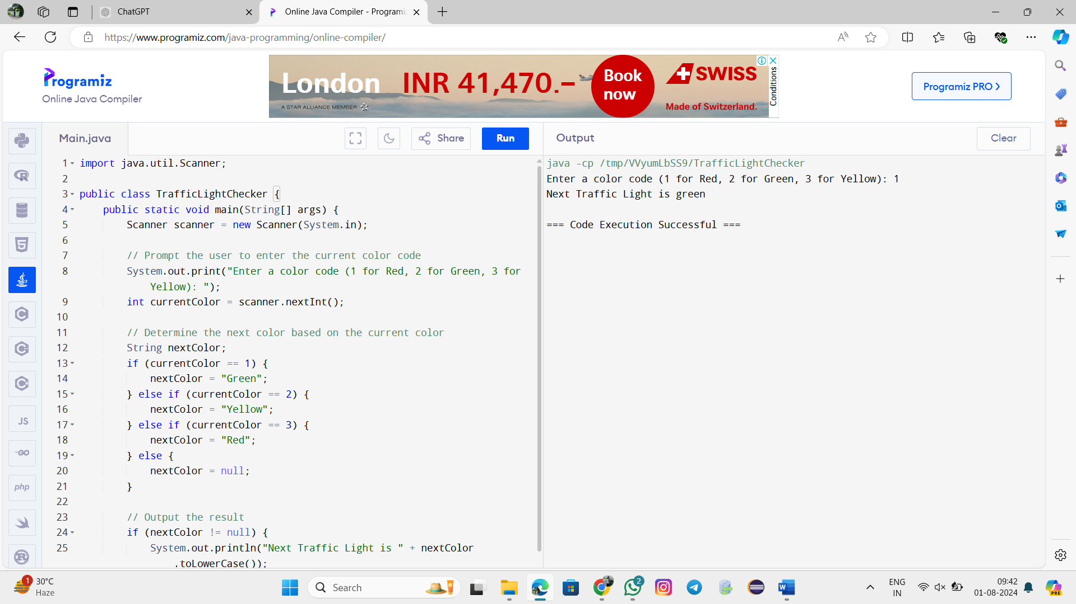

**Problem 5-3: Determining the next color for a stop light using switch:**

Re-write practice 5-2 using switch statement.

Task:

Implement practice 5-2 using switch statement and ensure the program alert users if they’ve entered any invalid value.

The TrafficLightSwitch.java file is available to help you get started.

**Coding:**

import java.util.Scanner;

public class TrafficLightChecker {

public static void main(String[] args) {

Scanner scanner = new Scanner(System.in);

// Prompt the user to enter the current color code

System.out.print("Enter a color code (1 for Red, 2 for Green, 3 for Yellow): ");

int currentColor = scanner.nextInt();

// Determine the next color based on the current color using switch case

String nextColor;

switch (currentColor) {

case 1:

nextColor = "Green";

break;

case 2:

nextColor = "Yellow";

break;

case 3:

nextColor = "Red";

break;

default:

nextColor = null;

break;

}

// Output the result

if (nextColor != null) {

System.out.println("Next Traffic Light is " + nextColor.toLowerCase());

} else {

System.out.println("Invalid color");

}

}

}

